Allensmore Neighbourhood Development Plan
2017-2031
Issues and Options Consultation
January 2018

Prepared by the Neighbourhood Plan Steering Group on behalf of Allensmore Parish Council
December 2017

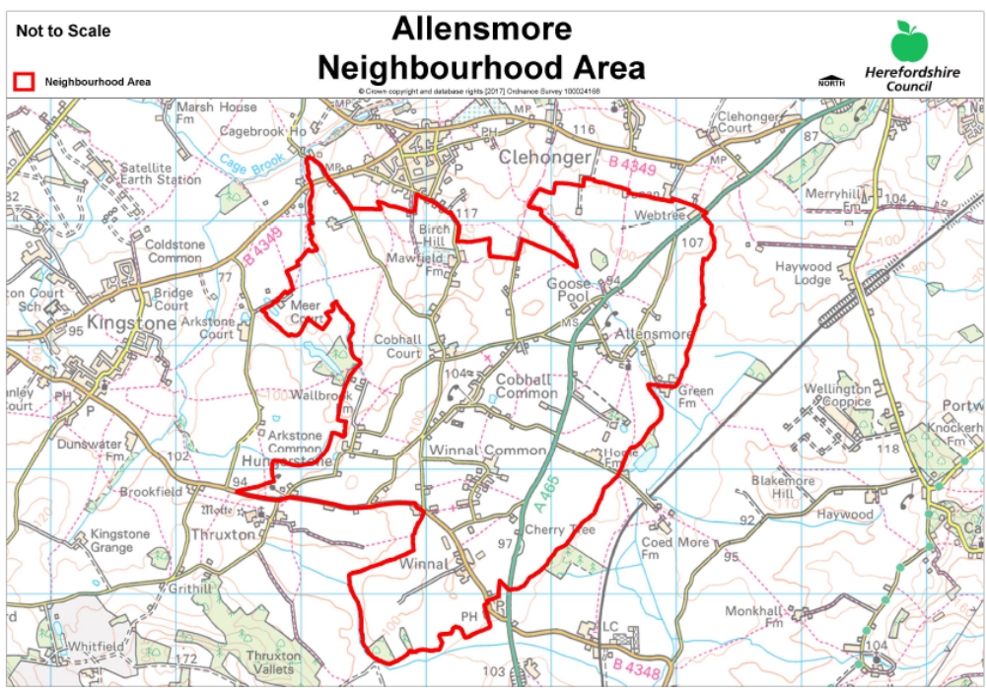

How to Comment on the Allensmore Issues and Options Document
The full 48 page Issues and Options document for Allensmore Neighbourhood Development Plan (NDP) can be downloaded from the NDP Section at Allensmore.org.uk. Printed copies are available to view at St Andrews Church, the village hall and the community library in the former Cobhall Common phone box. A few printed copies are also available to borrow on request from the parish clerk and NDP Steering Group members (details on Allensmore.org.uk).
The document has been prepared by the NDP steering group of local residents and parish councillors with the help of Kirkwells consultants. It sets out the key planning issues identified so far from the launch event in July and the steering group's own suggestions, and possible planning policy options for addressing these issues.
Please take some time to obtain and read the full document; we need your feedback to help us move forward with our Draft Plan for Allensmore.
To help you provide your feedback, we have prepared this separate response form to be used as you read the main document. It includes some key points and all the questions included in the main document, and copies are being delivered to all houses in the Allensmore NDP area. Comments from every individual (over 16) are encouraged (on separate forms please) and will be very welcome. Further copies of the form are available online at Allensmore.org.uk.
Copies of the main document will also be available for reading at the open drop-in event on Sunday 28th January 2018 any time between 2pm and 4pm at the village hall. Please come along and give us your thoughts and ideas if you would like to discuss anything in person.
You can submit comments and suggestions in several ways:
- Come along to the open event
- If you have Word, you can download and complete the response form on your computer and email to NDP@allensmore.org.uk
- Scan this form and email your completed response form to NDP@allensmore.org.uk
- Give or post your completed response form or written comments to any Steering Group member (see Appendix III of the main document or Allensmore.org.uk) or drop them into the comments box at church.
If you do not have enough room for your answers, continue on the back page or a separate sheet, or email us at NDP@allensmore.org.uk
Please return all comments by 11th February 2018.
Thank you for your time and interest. Your comments will help us with the next stage – the First Draft Neighbourhood Development Plan for Allensmore.
The information you provide will be made available to members of the NDP steering group and the consultants, Kirkwells only. It will be used only for the purpose of creating the development plan and any information published from these responses will be anonymous.
Q1a. Do you think the draft Neighbourhood Development Plan main document contains a good summary of the local context?
Yes ◻ No ◻ Don’t know ◻

Q1b. Please provide any further information if you think we have missed anything.

Draft Vision for Allensmore

To protect and enhance the parish’s rural way of life through gradual evolution and appropriate development which improves the quality of life for all the community whilst creating a more sustainable environment for the future.

Draft Objectives for the NDP

OBJECTIVE 1: HOUSING
To develop policies, within the framework of Herefordshire’s Core Strategy, which ensure that new housing development preserves and enhances aspects that people value, while meeting the current and future needs of both residents and businesses.

OBJECTIVE 2: THE ENVIRONMENT
Ensure that all housing and business development preserves the character of the parish and protects the landscape, so that its impact on the environment is minimised, with particular reference to water, sewage and soil management, as well as energy and water conservation.

OBJECTIVE 3: FARMING AND OTHER BUSINESS
Encourage new business initiatives which promote the economic well-being of the parish provided that they are in scale with, and sensitive to, the rural character of the locality.

OBJECTIVE 4: COMMUNITY FACILITIES AND INFRASTRUCTURE
Sustain and enhance existing community facilities whilst supporting appropriate new infrastructure as needed and desired by residents and businesses.

Q2a. Do you agree with the Draft Vision and Objectives?

Yes ◻ No ◻ Don’t know ◻

Q2b. Please provide any comments suggesting how they could be improved.

Policy Options for Landscape:
Q3a. Should Allensmore NDP include a planning policy such as this to protect local landscape character?
Yes ◻ No ◻ Don’t know ◻

Q3b. If Yes, is there anything else that we should include in the policy or supporting information (eg other important landscape features, flora and fauna etc?)

Q3c. Are there any specific and/or significant views that you believe should be protected?

Q3d. Or should the NDP be silent on landscape character and leave such policies to Herefordshire Council?
Yes ◻ No ◻ Don’t know ◻

Policy Options for Wildlife:
Q4a. Should Allensmore NDP include a planning policy to protect local wildlife?
Yes ◻ No ◻ Don’t know ◻
Q4b. If Yes, is there anything else that we should include in the policy or supporting / background information?

Q4c. Or should the NDP be silent on wildlife and leave such policies to Herefordshire Council?
Yes ◻ No ◻ Don’t know ◻
Policy 3 – Settlement Boundaries
Policy Options for Settlement Boundaries:
Q5. Should the NDP include Settlement Boundaries for the 3 settlements?
Yes ◻ No ◻ Don’t know ◻
Comments:

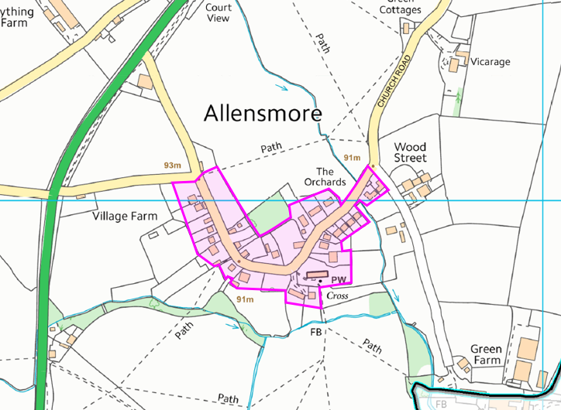
Map 2 Allensmore Settlement Boundary Options
(for bigger versions of these maps, please refer to the full document)

Policy Options for Settlement Boundaries:-
Q6. Do you think the boundary for Allensmore is …..
About right ◻
Should be extended ◻ If so, please describe in what way:

Should be made smaller ◻ If so, please describe in what way:

Don’t know ◻

Any other comments

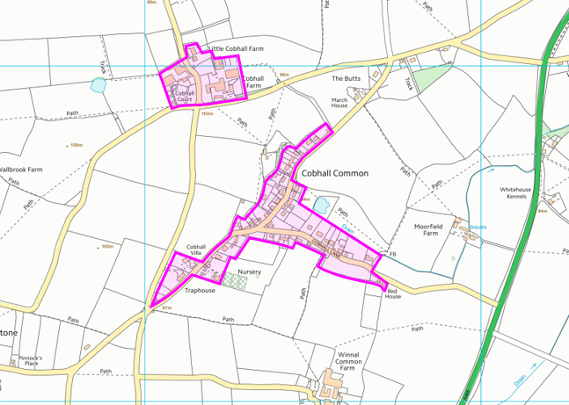
Map 3 Cobhall Common Settlement Boundary Options

Policy Options for Settlement Boundaries:
Q7. Do you think the boundary for Cobhall Common is …..
About right ◻
Should be extended ◻ If so, please describe in what way:

Should be made smaller ◻ If so, please describe in what way:

Don’t know ◻

Any other comments

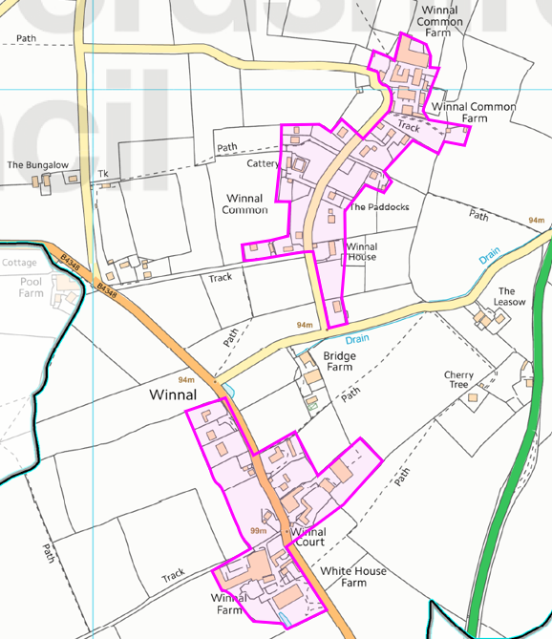
Map 4 Winnal Settlement Boundary Options

Policy Options for Settlement Boundaries:
Q8. Do you think the boundary for Winnal is …..
About right ◻
Should be extended ◻ If so, please describe in what way:

Should be made smaller ◻ If so, please describe in what way:

Don’t know ◻

Any other comments

Policy Options for Criteria in New Housing Developments:
Q9. Which planning criteria should be used to guide speculative new housing in the three settlements?

Please tick all that apply.
Brownfield ◻ Infill ◻ Scale / Size of development ◻ Access ◻ Parking ◻

Other ◻ Please specify

Q10. Do you think we need different criteria for each settlement?
Yes ◻ No ◻ Don’t know ◻

If Yes, please tell us about any specific issues that need addressing in each settlement.

Allensmore

Cobhall Common

Winnal

Policy Options for New Housing - Amount of New Housing:
Q11. The Core strategy requires at least 12 new houses between now and 2031. In your view, how many should we plan for?

This minimum number (12) ◻ 13 – 20 ◻ 21 – 30 ◻ 31 or more ◻

Policy Options for New Housing - Location of development:
Q12. How should these new homes be spread across the area?
About evenly across the three settlements ◻ Not evenly ◻
Please explain

Policy Options for New Housing - Scale of each development:
Q13. Should these developments be for: (tick all that apply)
Single houses ◻
Small scale developments of 2-3 houses ◻
Medium scale development of 4-10 houses ◻
Larger developments - over 11 houses ◻

Note - affordable housing can only be required to be provided in schemes of 11 or more houses, so if we only have schemes of 10 or fewer houses, we may not be able to have any new affordable housing in the settlements.

Policy Options for New Housing -Types of Housing:
Q14. Which of the following would you like to see included in the new housing? (tick all that apply)

Starter homes of one or two bedrooms ◻
Family homes (three bedrooms) ◻
Executive homes (four or more bedrooms) ◻
Adapted / easy access homes ◻
Supported housing / retirement homes ◻
Conversion of existing non-residential buildings (e.g. barns) ◻
Other ◻ Please specify

Policy Options for New Housing - Housing Tenure:
Q15. What types of housing should be included in the new homes? (tick all that apply)

Privately rented homes ◻
Privately owned homes ◻
“Affordable housing” for sale ◻ (Note: this is not the same as low cost market housing)
“Affordable housing” for rent (eg registered provider) ◻
Shared ownership (occupant and registered provider) ◻
Other ◻ Please specify

Policy Options for New Housing – other Housing Policy:
Q16. Are there any other policies about housing that you would like to see included in the NDP?

Yes ◻ If so, please describe what to include:

No ◻ Don’t know ◻

Policy Options for Local Economic Development:
Q17. Do you think the Allensmore NDP should include a policy supporting conversions of former agricultural buildings to promote local economic development?
Yes ◻ No ◻ Don’t know ◻

Comments

Q18. Cycleways

Would a cycleway be well used and/or be useful to you or your family?

- from Belmont to the village hall Yes ◻ No ◻ Don’t know ◻

- from the village hall to Lock’s Garage Yes ◻ No ◻ Don’t know ◻

Q19. Road signs

  - Is there a need for additional directional signage?
Yes ◻ If so where?

No ◻ Don’t know ◻

  - Do you feel “slow down” or similar signs on the A465 would make it safer for parishioners or visitors?
Yes ◻ If so where?

No ◻ Don’t know ◻

Q20. Litter and illegal dumping of waste

- Is illegal dumping of waste a problem?
Yes ◻ If so where?

No ◻ Don’t know ◻

- Would you support/take part in an annual “litter pick” along the length of the A465 through the parish and/or along our side roads?
Yes ◻ No ◻ Don’t know ◻

Q21. Traffic speed.

  - Given that the A465 divides the settlement areas and is subject to the national speed limit of 60 mph, would you support pursuing a lower speed limit with the relevant agencies?

Yes ◻ No ◻ Don’t know ◻

  - As a resident of Allensmore, Cobhall Common and Winnal would you support pursuing a lower speed limit in the centre of your community with the relevant agencies?

Yes ◻ No ◻ Don’t know ◻

  - Would you support the installation of speed bumps or other traffic calming measures?

Yes ◻ No ◻ Don’t know ◻

Q22. Can you suggest any additional features/structures which the parish lacks and that would improve life in Allensmore (for example, public transport)?

Policy Options for Local Infrastructure:
Q23. Do you think the Allensmore NDP should include a policy protecting the village hall as a local community facility and supporting investment in new or improved facilities?
Yes ◻ No ◻ Don’t know ◻

Comments

Q24. Do you think the Allensmore NDP should include a policy to encourage improvements to the facilities at St Andrews and by so doing enable a wider use of the church building?

Yes ◻ No ◻ Don’t know ◻

Comments

Q25. Please tell us a little about yourself.
This helps us to check if we have views from a wide range of people living in the parish.

Which area of the parish do you live in?
Allensmore ◻ Cobhall / Cobhall Common ◻ Winnal/ Winnal Common ◻
Other area ◻ Please specify

Your age?
Under 30 ◻ thirties ◻ forties ◻ fifties ◻ sixties ◻ older ◻

Number of children aged 16 or under usually living in your household?

How long have you lived in this parish?
Under 5 years ◻ 5 to 10 years ◻ 10 – 25 years ◻ over 25 years ◻

If you work or are in full time education, where do you mostly do so?
Not applicable ◻ Home ◻ Allensmore area ◻ within 10 miles ◻ further than 10 miles ◻

Would you like to make any further comments?

